COMPUTER ARCHITECTURE & SYSTEMS LAB

Day 4 Assignment: GPUs & Thermal Management Systems
Topic: Graphics Processing Unit Architectures, Heat-Dissipation Dynamics, and Thermal Infrastructure Comparison
TASK 1: HARDWARE PROFILING
1. Graphics Subsystem Identification
Identifying the processing infrastructure responsible for rasterization, complex geometric operations, and parallel computing streams.

Hardware Parameter | Identified Specifications & Values
GPU Brand | NVIDIA Corporation
Model Number / Name | GeForce RTX 4070 SUPER
Architecture Type | Dedicated GPU (Discrete PCIe Add-in Card with 12GB GDDR6X VRAM)
Method of Verification | Verified via Windows Task Manager (Performance Tab → GPU 1) and Device Manager.

TASK 2: THERMAL INFRASTRUCTURE INSPECTION

Thermal Subsystem Component Mapping
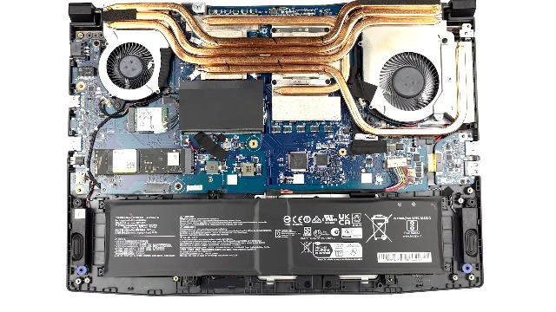
High-performance computing chips generate immense thermal energy under dense parallel processing loops. Effective heat transference keeps components beneath critical throttling thresholds.

[Student Lab Documentation —Cooling Infrastructure Screenshot / Photo]
Affix evidence of your device's physical cooling assembly or virtual configuration map.
Label arrows directing to: (1) Active Fans, (2) Copper Heat Pipes/Cold Plate, and (3) Fin Stack Heatsink.

Core Component Functionality Definitions:

  - Thermal Paste / Interface Material (TIM): Fills microscopic structural air gaps between the silicon GPU die and the metallic contact base to minimize thermal contact resistance.
  - Copper Vapor Chamber / Heat Pipes: Utilizes phase-changing internal fluids to rapidly transport structural thermal loads away from the silicon die toward the cooling fin array.
  - Aluminum Heatsink Fin Array: Maximizes overall outer structural surface area to transfer heat out into the surrounding environment via convective conduction.
  - Axial Cooling Fans: Dynamically forces high-velocity cool air through the aluminum fins to accelerate heat dissipation.

TASK 3: COMPARATIVE THERMODYNAMICS
3. Air Cooling vs. Liquid Cooling Paradigms
Choosing an architectural cooling design requires balancing systemic acoustic targets, long-term operational resilience, and thermal performance envelopes.

Evaluation Air Cooling Solutions (Heatsink & Liquid Cooling Solutions (AIO or Factor Fan) Custom Loop)
Thermal Efficiency | Highly stable but limited by systemic ambient air temp. Great for bursts; slower thermal saturation capacity under sustained loads. | Superior thermal capacity. Liquid absorbs significantly more energy per unit volume, holding operational temps flat over long periods.
Financial Cost | Low to Moderate budget overhead ($30  - $100 baseline range for premium configurations). Cost-efficient with zero failure paths. | High to Premium cost overhead ($90 -  $350+ for basic All-In-One (AIO) loops or expensive open custom structural pathways).
Maintenance & Risk | Extremely low maintenance. Periodic cleaning of accumulated dust using compressed air. Zero risk of component-killing fluid leaks. | Moderate to High. Pump mechanical lifespans are finite. Permeation risks demand liquid top-offs over long horizons; leak risk present.

TASK 4: PRODUCTION PC ARCHITECTURE JUSTIFICATION

4. Structural Hardware Specification Brief: Gaming & Streaming Build

Selected Thermal Infrastructure: All-In-One (AIO) Liquid Cooling System

Architectural Engineering Justification:
For a dedicated configuration running intense graphics-heavy games simultaneously with live streaming platforms during complex live events like IPL matches, an AIO liquid cooling solution is highly optimal. Encoding live video bitstreams alongside intense gaming tasks pushes both the multi-core CPU and high-end discrete GPU to maximum sustained power draws, saturating traditional air towers rapidly. Liquid cooling maintains stable operational temperatures, preventing thermal throttling and framing drops that degrade the broadcast stream. Furthermore, isolating thermal exhaust directly to the case boundaries reduces acoustic fan noise, ensuring clean, noise-free audio capture during live production streams.

